CSBJ – Branded Content #1
Subject Line: Investors – Is Your Tax Sheltering Plan Bulletproof?
Regardless of whether you invest in the conventional market or participate in more sophisticated investments like cryptocurrency, we are all sitting in a world of unknowns right now. However, all politics aside, there are two things that are certain. First, is that the trillions of dollars in government aid will need to be paid back. Second, is that this expectation foreshadows what recourse will most likely be taken, taxes. So, in anticipation of this impending tax event, does your investment strategy also include an optimal tax shelter plan?
The government has granted you the boon of many forms of tax sheltering vehicles, including the Self-Directed IRA (SDIRA). It is no secret, and yet Self-Directed IRAs are still one of the most underutilized vehicles for tax relief on alternative investments by new and even seasoned investors! SDIRAs are available for individuals in the form of Traditional or Roth IRAs and Solo 401ks, and for the entrepreneurs/business owners with SEP and SIMPLE IRAs.
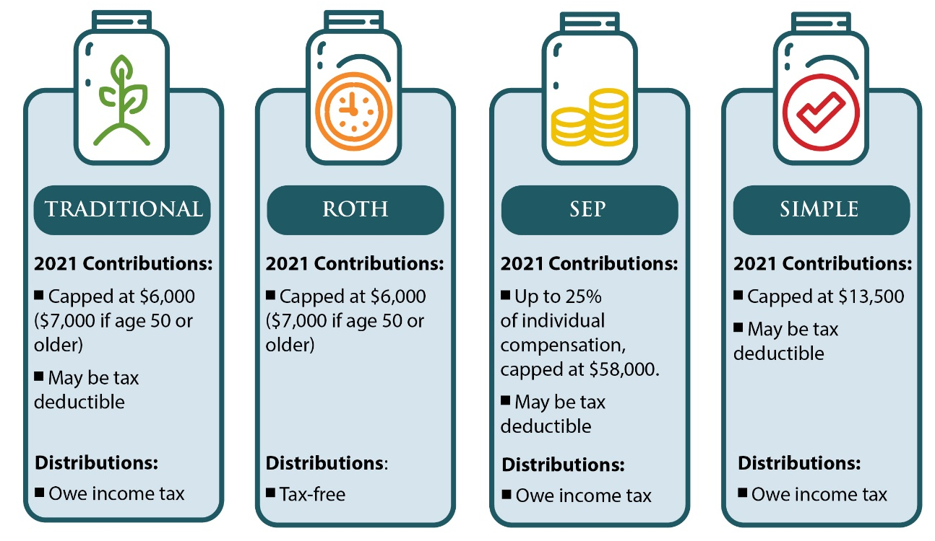
Since its inception in 2007, Preferred Trust Company has empowered thousands of Americans to invest in alternative assets within a SDIRA. Preferred Trust Company was one of the first custodians to offer segregated custody of cryptocurrency investments for their clients. Per the IRS, digital currency is treated as property for tax purposes, which is why investments in digital currency outside of a qualified plan it is subject to capital gains tax rates. Capital gains tax is determined by multiple factors such as investment duration and your income tax bracket on the state and federal level. However, investors utilizing a SDIRA can invest in digital currency and compound capital gains tax-deferred or tax-free, depending on the type of account. Let us put that into perspective by breaking down the numbers for investing with cash versus investing with qualified funds.
For this example, let us say you purchased 20 Bitcoin with cash and 20 Bitcoin in an IRA at $3,500 per unit toward the end of 2018. You held onto the digital currency for about two years and then sold it near a peak in mid-February of 2021 at $55,000 per unit. Per the IRS, this would be considered a long-term hold, so the long-term capital gains tax rate would apply. Now it is time to compare your net income with the cash investment vs the IRA investment, reflected in the chart below:
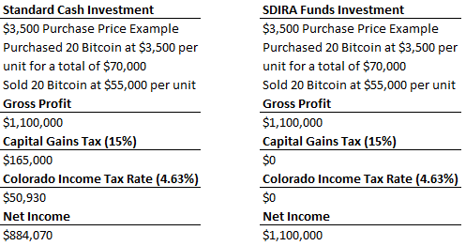
As you can see, that is a significant amount of capital gains that is sheltered from taxes and can help supplement the growth of your retirement nest egg. So, can you say you are doing everything you can to protect your hard-earned money? If you cannot answer this question with confidence, you could be overdue on a visit with your tax advisor to discuss your options.
Self-Directed IRAs open the door to tax sheltered investments in alternative assets, such as real estate, precious metals, natural resources, private equity, and so much more. To learn more about Self-Directed IRAs, CLICK HERE download our FREE Whitepaper “SDIRA: Fact or Fake”.
SPECIAL PROMOTION: Now until December 31st, 2021, Preferred Trust will waive the establishment fee and first year administration fee for all new accounts. Get started today by filling-out an application online, no promo code needed to take advantage of this offer. Have more questions? Give us a call 888-990-7892 or CLICK HERE to schedule a no obligation consultation to get started on securing your financial future today!

