Email Subject Line: Self-Directed IRA Webinar: What’s Fact or Fiction?
Hello {recipient.firstname},
Do you understand how a Self-Directed IRA works? There is often a lot of confusion and misinformation when it comes to the perception of Self-Directed IRAs and custodians. Unfortunately, this perception can steer investors away from what could be a beneficial wealth building tool to bolster their retirement strategy.
You are receiving an exclusive invitation to attend the Virtual Seminar “Self-Directed IRAs: Fact and Fake”. Join Preferred Trust Company on Thursday, October 21st at 9:00am where we will debunk common industry misconceptions and show you how a Self-Directed IRA can be one of the most dynamic tax-sheltering tools you can fold into your portfolio.
Click the image below to register for this FREE virtual event!
CTA link - https://info.preferredtrustcompany.com/lvrj-fact-fake-webinar-registration
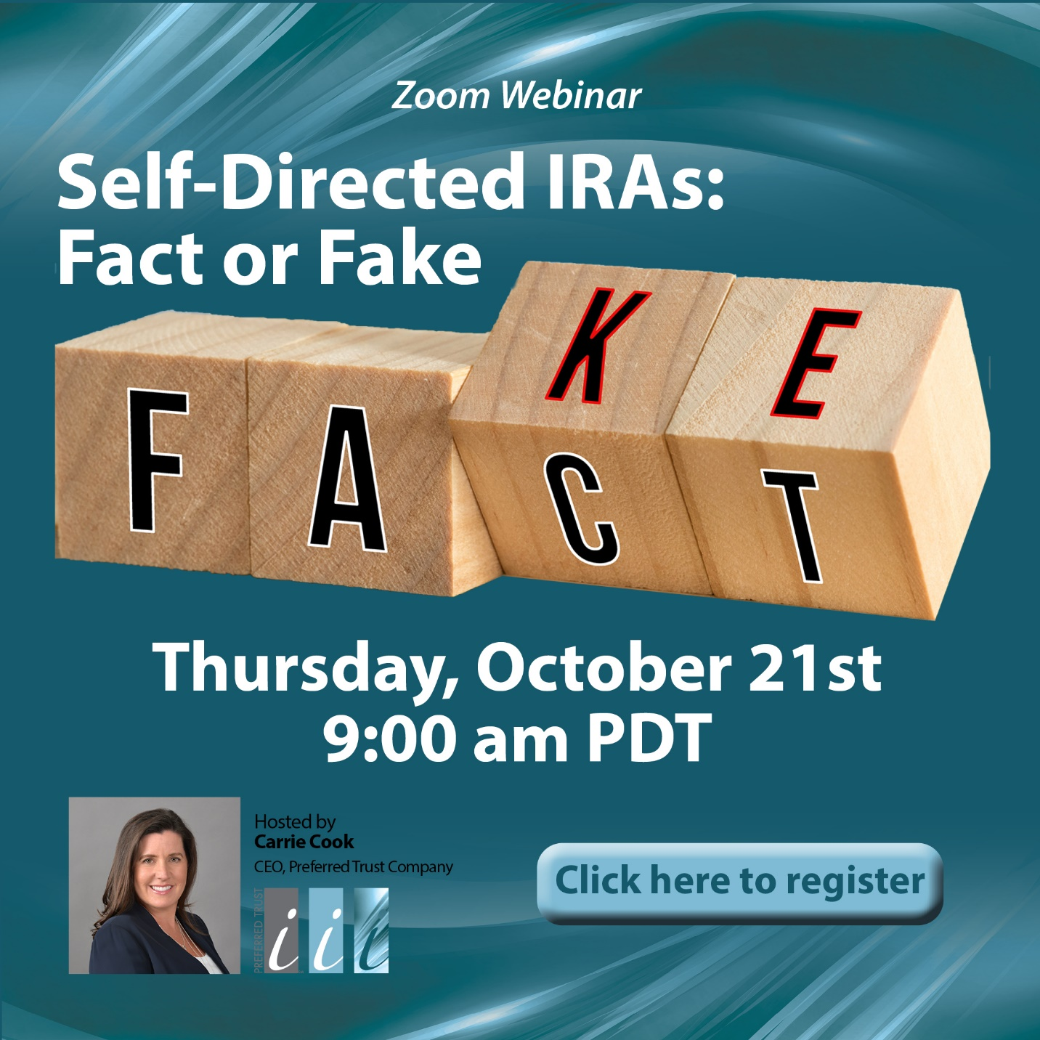
Let us prove that we are the best! Give us a call today at 888.990.7892 or Click Here to schedule a no obligation consultation if you are ready to discuss how we can help you realize your goals for 2021 and beyond!
