Headline: Don’t Be a Rule Breaker! – IRA Rental Property Guide
Real estate is one of the most popular investments to leverage within a Self-Directed IRA. It is a familiar asset if you own your own home or other type of property, it offers diversification from traditional investments, and the rental income and/or capital gains funnel in tax deferred or tax-free depending on the type of account. While the general concept of investing in a rental property through a Self-Directed IRA may be similar to investing outside of a qualified account, there are a handful of rules enforced by the IRS that makes the management of this investment quite a bit different. This is because your retirement account is meant to benefit you when you retire, not before.
At Preferred Trust Company, we want to see our clients’ investments thrive and help them realize their retirement goals, which is why we have put together the most frequently asked questions about managing a rental property in an IRA and how to avoid common mistakes.

What type of properties can I own with my Self-Directed IRA? Are there any restrictions on the type of property I can purchase?
With an IRA, you are not limited to investing solely in residential real estate. Your IRA can hold various investment property types, including commercial buildings, retail properties, raw land and acreage (improved or unimproved), single family or multi-unit homes, condos or townhomes, mobile homes, apartment buildings and much more.
Your IRA can also purchase foreclosure property at an auction as long as the property has already been foreclosed upon. You may think that investing with an IRA would be too complicated or to slow to be able to meet the requirements and deadlines typical of a foreclosure auction. However, with an IRA at Preferred Trust Company there are three different ways you can easily purchase a property at auction.

Can I personally use the property that was purchased with my IRA funds?
No, that would be considered a “self-dealing” transaction which is prohibited by the IRS. Any investment you make with a Self-Directed IRA, including a rental property, is to be used strictly for investment purposes only. This means that you and other disqualified persons may not receive direct or indirect benefits from an asset that is owned by your IRA, even if the IRA only owns a portion of the investment.

Can I rent the property to family?
That depends on the family, and we are not saying that to spark a family feud. Disqualified persons encompass lineal “ascendants” and “descendants”, such as parents, grandparents, children & their spouses, and great grandchildren. Other disqualified persons include the institution that holds custody of your IRA, as well as fiduciary advisors. Your sister, brother, cousins, friends, and others that are not lineal in relation are considered qualified persons and could rent the property if that is your intent.
Keep in Mind: You cannot sell or purchase a property from yourself or disqualified persons. This would be construed as a direct or indirect benefit.
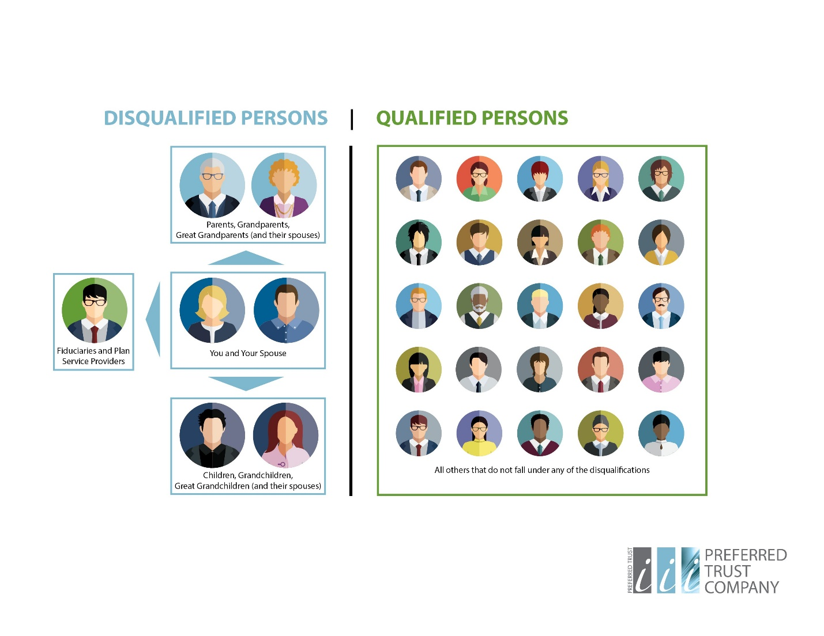

Can I act as property manager for my investment property?
Acting as property manager would be considered a “self-dealing” transaction and is prohibited by the IRS. All services and costs for the upkeep of your property must be outsourced to third parties not associated with you or disqualified persons and must be paid through your IRA accordingly. Services include any kind of property maintenance and management, i.e. cleaning/landscaping/pool cleaning services, repairs, property management, realtors, etc.

Do expenses such as utilities, repairs, renovations, taxes, and mortgage payments need to be paid from the IRA account?
Yes, any expenses for an IRA-owned property must be paid by the IRA directly. The IRS prohibits the use of personal funds to pay for expenses incurred by an IRA-owned property. However, if the property is only partially owned by the IRA, then the IRA pays based on the percentage of ownership. For example, if the IRA owns 45% of the property, then the IRA will pay 45% of utilities, repairs, renovations, etc.
If eligible, you can make your annual contribution to the IRA and use those funds to help pay for expenses. However, you cannot contribute more than what you qualify to contribute annually to offset costs.

Can the rental income from the property in my IRA be sent to me personally?
In order to maintain the tax deferred or tax-free status of the rental income, all transactions MUST be processed through and held in your IRA account. If you wish for the rental payment amounts to be withdrawn/distributed to you personally, the payment must be deposited into the IRA first and then the custodian can process a distribution from the IRA. If you are not yet the age of 59 ½ or older, this distribution could be subject to tax consequences and penalties.
Special Promotion! If you are interested in adding tax-deferred or tax-free passive income from rental properties to your retirement strategy, scan the QR code or give us a call at 888.990.7982 to schedule a consultation with one of our Self-Directed IRA specialists at your convenience. From now until December 31st, 2021, Preferred Trust Company will waive the establishment fee and first year administration fee for all new accounts. Visit our website and apply online to take advantage of this offer today!
PREFERRED TRUST COMPANY, LLC (“Preferred Trust”) | 2140 E Pebble Road | Suite 140 | Las Vegas, NV 89123 | 702.990.7892 | www. preferredtrustcompany.com | Financial Institutions Division of Nevada License No. TR1002. Preferred Trust performs duties of a custodian and as such, does not sell investments or provide investment, tax, or legal advice. Preferred Trust is committed to safeguarding all non-public personal information provided to us by our customers. Preferred Trust collects, retains, and uses customer information where we reasonably believe that it will help administer our business or provide services to our customers. We collect and retain customer information only for specific business purposes and upon request will inform customers why we are collecting and retaining the information. We use information to protect and administer records, accounts, and funds; to comply with certain laws and regulations; to help us design or improve our services; and to understand the financial needs of our customers. Preferred Trust is an accredited member of the Better Business Bureau.

